Updates to the Climate-ready Revegetation Guide. A guide for natural resource managers

Over time, the websites used in the Guide will change, experience technical difficulties, or perhaps disappear altogether. Listed below are amendments to step 2 and some additional useful information.

Amendments

The Atlas of Living Australia (ALA) has made some amendments to their mapping functions and this entails changes to the instructions in the Climate-ready Revegetation Guide.

Step 2.2 Map the current distribution of the species: Point 1. After selecting the ‘Mapping and analysis’ section, click on ‘Explore the spatial portal’ tab.

Step 2.3.1 (page 8) A log in is now required before points can be imported. The account needs to be activated via your email before access is allowed.

Step 2.3. 2 page 8, the second point under ‘To produce a scatterplot’, step 4. Instead of entering the temperature and precipitation into the first and 2nd boxes respectively, we now only use the 2nd box (Add from search). Type in Bio12 and click on Precipitation – annual (Biol12) when it appears, tick the box and ‘1 layer selected’ will appear at the bottom. Go back to the box and type in’Bio01’ and click on ‘Temperature – annual mean (Bio01) when it appears. Tick the box and now ‘2 layers selected’ appears. Continue as per previous instructions.

Additional information

- How to find the decimal latitude and longitude and the current mean annual temperature and annual precipitation for your site

To place your site on the ALA distribution map (Step 2.3.1) and the ALA scatterplot (Step 2.3.2), the decimal latitude and longitude values are needed and it may be handy to know the environmental variables of the site (especially if using http://www.nswnichefinder.net/). An example is given below.
To Find current mean annual temperature and & annual precipitation for your site:
- Go to http://www.ala.org.au (link is in Step 2, 2.1.1)
- Click on Mapping & Analysis |Browse mapping
- Add to map | Layers
- “Add from search” box, type in “Bio01” (& select) and then “Bio12” | Next
- Change opacity to ~30%
- Double click on map to get closer to site. On the bottom right hand side of the screen, as you hover over the site, the values will appear (see Figure 1) (Taken from Booth, 2016, EMR, 17, (3) 228-234).
The decimal latitude and longitude will also appear. Decimal lat / longs can also be viewed on the distribution map of the species.

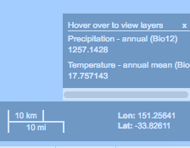
Figure 1. An example of the current annual precipitation, annual mean temperature, decimal latitude and longitude for Penrith, Sydney.

- How to use nswnichefinder for distribution maps and scatterplot

Go to http://www.nswnichefinder.net/ (or use the link in Step 2, 2nd paragraph)

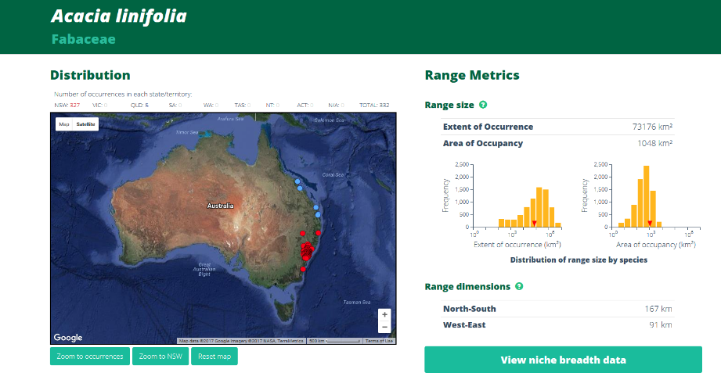
- Click on “Species” e.g. Acacia linifolia
- Click on ‘view niche breadth data’
- Click on ‘annual mean temperature’
- Next page: select annual precipitation for y axis
As shown in Figure 2 below.

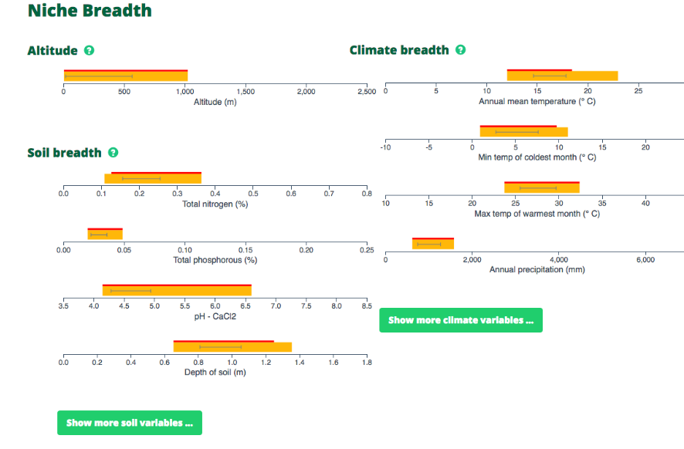
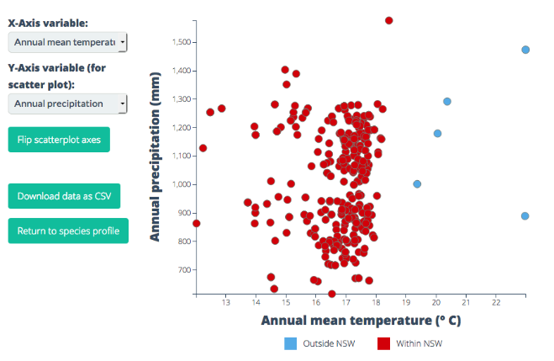

Figure 2. An example using nswnichefinder

