ABSTRACT TEMPLATE FOR THE REGIONAL ABC SYDNEY

First Author^{1,2}, Second Author², Third Author² and Last Author ^{1,2}

¹ Department, University / Institute, City, Australia.

² Department, University / Institute, City, Australia.

INTRODUCTION
This page contains information about the abstract submission process and represents the template you must use to format your abstract. All abstracts must be emailed to abcsydney2020@mq.edu.au by 30 October 2020. All abstracts must be submitted as PDF files and must be smaller than 8 MB. You will be notified early November if your abstract is accepted.
Keep the introduction focused. Explain how this study fits into a larger area of research and what this study aims to contribute. If you use innovative methods, highlight which aspects are new. Try to avoid the use of unnecessary or uncommon abbreviations.

METHODS
The abstract should be one A4 size page (210 x 297 mm), with two columns of text, justified. The top, bottom and right margins should be 15 mm, and the left margin should be 20 mm. Type font is Calibri 10 pt. Please use this formatting template. The Organising Committee reserves the right to reject abstracts that do not adhere to the formatting requirements.
The title (bold caps), authors and author affiliations should be centred across the top of the page. Use numerical superscripts to distinguish authors who are from different institutions.
The body of the manuscript should be divided into the following sections: Introduction, Methods, Results and Discussion, and Conclusions. Text within each section should be justified, with 10 mm paragraph indentations. Use one line space between sections.

RESULTS AND DISCUSSION
Up to one figure and one table may be incorporated within the document and must be referenced in the text (Figure 1). Only use colour in the figures if strictly necessary. Captions must be legible and placed below each figure, and above each table. Tables may extend across two columns, although remaining within the specified page margins (Table 1).
Use numbers in square brackets [1,2] to cite references within the text and format references at the end of the abstract as shown on this page.

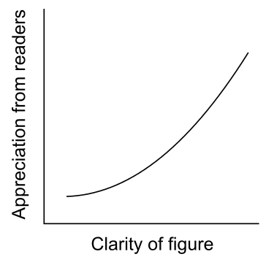
Figure 1 Where possible, show individual data points/curves in your figure. In the caption, write out in full the abbreviations used in the figure. The font of the caption should be Calibri 10 pt italics.

CONCLUSIONS
Summarize your main findings and place the findings in the larger context of your field. Use as plain English as possible – avoid jargon. Conclusions should be based directly on the data presented in this study.

ACKNOWLEDGEMENTS
Acknowledgments are optional.

REFERENCES
[1] Bigname AB et al. J Biomech 40: 3121-9, 2018.
[2] Otherbigname et al. Clin Biom 50: 158-65, 2019.
Table 1: Tables that extend across both columns should be placed at the bottom of the abstract.
 | Group 1 | Group 2 | Effect size | 95% confidence intervals (p-value)
Variable 1 (Units) | 3.1 ± 0.6 | 2.4 ± 0.7 | 1.12 | 0.6 to 0.8 (0.023)
Variable 2 (Units) | 6.3 ± 1.1 | 4.2 ± 1.3 | 1.75 | 1.5 to 3.2 (0.002)

