Risk Assessment tool
Vulnerable people returning to work
This risk assessment tool is for use by MQ managers and supervisors who have people who are vulnerable returning to work or visiting in the current COVID-19 environment. MQ should be able to provide reasonable adjustments for those wanting to return.
Note: The supervisor / manager will, assess the need for and arrange worker / visitor / area specific requirements. This risk assessment tool includes addressing overall COVID-19 basic considerations already outlined under the MQ COVID Safe Plan. For further information go to the MQ COVID-19 webpage.
Name of worker
Position title
Department / Portfolio
Manager / Supervisor
The assessment needs to be looked at under a changing risk environment. The current advice from the Australian Health Protection Principal Committee AHPPC dictates the actions needed to be implemented as the risk environment changes.
The risk environment consists of the following three scenarios and included control measures:
Risk environment | Actions
- No COVID-19 cases in their community  When the current level of COVID-19 cases in most communities is low. This means that people, even those at higher risk of more severe disease, can return to normal activities and interactions with physical distancing and other appropriate controls in place. | - Maintain physical distancing 1.5m  - Maintain good hand and respiratory hygiene  - Download the COVIDSAFE app  - Stay at home if you have cold or flu-like symptoms  - Follow the MQ COVID Safe Plan  - Stay up to date
- Low numbers of cases in their community  As the risk increases it becomes time to implement additional measures. Be clear about when to initiate these. | - All of the above plus  - Determine additional level 2 actions via the considerations from the table below  - Implement level 2 actions
3. Increasing numbers of cases in their community | - All of the above plus  - Avoid going out except for essential activities (this may include work)  - Work from home if there is ongoing exposure at work  - Consider your level of comfort to participate in workplace activities based on the risk management strategies put into practice in the workplace
If case numbers increase people need to think about other measures in addition to physical distancing and hygiene measures. Everybody needs to think about their activities and interactions and how these might affect their risk of exposure to COVID-19.
There are different degrees of risks of virus exposure, depending on the activity, setting or event. Some types of activities, events and settings may increase risk of contracting COVID-19 illness.
These include activities that:
- are in closed or indoor environments
- have large numbers of people in close contact (e.g. public transport at peak hour, weddings or other large gatherings)
- require physical activity and close contact (e.g. dancing or contact sport)
- require vocalising in an indoor environment (e.g. choirs or singing in church;
- require sharing objects with others (e.g. utensils at a buffet)
- require sharing accommodation or amenities with others (e.g. a cruise ships); and
- are longer, the risk increases with time (for exposure and transmission)

Consideration |  | Controls / Comment / Information | Risk rating after controls
1 | Self-disclosed risk factors:  - Aboriginal and Torres Strait Islander people 50 years and older with one or more chronic medical conditions  - People 65 years and older with one or more chronic medical conditions  - People 70 years and older, and  - People with compromised / impaired immune systems  - Other
2 | - Supporting medical information if required  - Has the person been assessed by their doctor as being of increased risk and high risk of severe illness if they contract COVID-19?  - Are vaccinations up to date, especially influenza | Has their doctor provided a COVID-19 Action Plan  As community transmission increases so should regular reviews with their doctor.
3 | Transport to work  - Own  - Shared/public | Consider case hotspots across their travel if by public transport
4 | Workplace activities undertaken by the worker and the areas they will be working in;  - Office based  - Research based  - Lab based  - Other  Is relocation of workstation required / an option? | 1.5m should always be maintained around vulnerable persons and as the risk environment increases consider increasing the physical distancing from others.  Change or avoid increased risk activities such as prolonged indoor activities or high contact roles
5 | Are people required to;  - Share Workstations  - Share equipment  - Other | How will this be managed?  No shared items or equipment is preferred
6 | List additional personal protective equipment (PPE) required due to COVID-19 in light of vulnerable people eg masks, respirators, and instruct on use and maintenance.  - Yes No
7 | Will your people be;  - working with other workers, students, volunteers, the wider community  - going out into the community and vulnerable cohorts | E.g. Is zoom an option for communication?  Avoidance of face to face and less exposure to multiple people is preferred.
9 | Report any incidents, accidents, health and safety issues or concerns asap (within 24 hours) to manager and online via ROAR system.
10 | Other
11 | Store any completed risk assessment in a secure place, remember privacy and record management. | RA made available to those affected by it.

When assessing a vulnerable person’s return/visit to campus points to discuss include;
- Take care of yourself and seek clarification from your manager as needed
- Only undertake activities within the role, discuss any changes with your manager
- Take note and follow existing signage
- Reiterate physical distancing, hand and respiratory hygiene, staying at home and being tested if concerned / symptomatic
- Consider how personal equipment e.g. keyboards, desk, equipment brought to campus will be managed
- Consider continuing to work from home if indicated
- Walk through the workplace with your vulnerable person on their return to work
- Take into consideration cases in the persons entire community – where they live; during transit; all workplaces
- Remember this is their personal risk and will differ from those making the assessment.
Australian Government Dept. of Health Resources:
(AHPPC) statement on recommendations for managing of health risk as COVID-19 measures lift
Advice for people at risk of coronavirus (COVID-19)
Coronavirus (COVID-19) advice for people with chronic health conditions
Who undertook the assessment -
_{Manager / Supervisor:}
_{Person / Worker}
_{Work Health & Safety Adv:} |  | _{Date:}

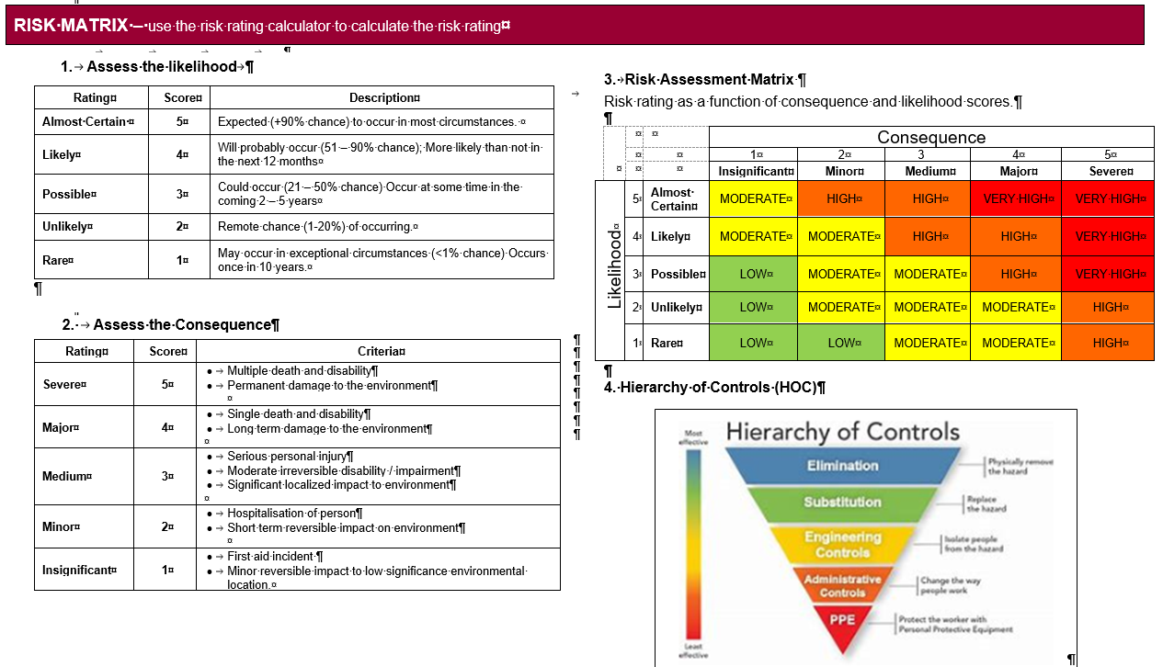

To assess a task, event or activity go to the Health and safety risk management page for a generic H&S risk management template.

