MACQUARIE UNIVERSITY COURSEWORK SCHOLARSHIPS
REVIEW. FINAL REPORT – August 2008
Review Working Party
Professor Mitchell Dean, Dean, Division of Society Culture Media and Philosophy;
Ms Kathlyn Smart, Assistant Registrar, Coursework Studies Section;
Mr Brian Hurd, Manager, Coursework Scholarships and Prizes Unit;
Mr Jason Elias, Manager, Student Recruitment, Marketing Unit.
Executive Summary
In the first year of introduction, the new Macquarie Coursework Scholarships were met with positive responses from students, parents and schools alike. Five new Macquarie scholarships were introduced in 2008, a total budgeted cost of $791,000 pa and supporting 130 students. The projected non-discretionary budget for all Macquarie sponsored coursework scholarships for 2009, including the wind-down of the previous program, is $1.805.250 and supporting some 260 students annually (refer Attachment 3).
The selection criteria for the new programs were developed with a focus on social inclusion and equity, whilst also recognising academic achievement. Students were selected on their demonstration of outstanding character, maturity, common sense and capacity to triumph over hardship. The disadvantages ranged from financial, carer responsibilities, non- English speaking or Indigenous background, effects of trauma and/or abuse, a long-term medical condition or disability, or from coming from a rural or remote area. This focus supports the emerging Macquarie strategic direction of equity in that university studies could be available to many others if the entry ‘playing field’ was more even.
One Merit Scholarship recipient reported in a recent focus group that “… I was so unsure of what I wanted to do. My other choice was between commerce and science at the University of Sydney and that was actually my idea in lodging my application. But when the Scholarship thing came out, I just changed my preferences and put Macquarie first.”
Responses such as this validate Macquarie’s decision to re-develop its scholarship programs and recognition that this is an integral student recruitment strategy.
The sustained value from scholarships is in Macquarie having a centralised, coordinated scholarship program which drives the strategic vision and which has a strong interface with Marketing, External Relations and teaching Departments, in addition to developing a coordinated relationship with the student cohort.
With the introduction of the new Macquarie scholarships and of the centralised Scholarships & Prizes Unit, a number of strategies are now being developed to support improvements in a coordinated approach to student engagement, the relationship with industry and corporate sponsors, and overall, in the development of policy and processes that will support how the university interfaces with all stakeholders in this arena.
A Progress Report of this program was presented to the universities Senior Management Group by Professor Mitchell Dean on 30 July 2008. Feedback from this has been incorporated into the final document.
Background
In 2007 Macquarie undertook a review of coursework scholarships offered by the university. An integral part of the review process was an analysis of the competitor market and alignment with the range of Commonwealth Scholarships.
As a result of this process, five new scholarships were recommended for development with either equity or a merit base, and were developed and implemented late 2007 for the 2008 student intake. With the implementation of the new Macquarie Scholarships, there was an agreement for a significant increase in the budget of $188,000 required to wind up the current programs in 2008, to the new program budget of $791,000 for 2008.
In summary, the new programs on offer provide:

Macquarie Merit Scholarships
This merit based scholarship is for applicants with a UAI of 98.5 or above and must also be able to demonstrate outstanding character and maturity, eagerness and passion, and capacity to triumph over hardship. A value of $12,000 pa, supporting 10 students.

Macquarie Education Costs Scholarship (MECS)
This equity based scholarship is designed to support recipients whose opportunities to study at university may have been hampered by situations out of their control. Applicants must be eligible for a Commonwealth Scholarship. A value of $4240 pa, supporting 50 students.

Macquarie Accommodation Scholarship (MAS)
This scholarship is designed to support recipients whose living situation may have hampered their ability to study at Macquarie, and who would benefit from relocation. Applicants must be eligible for a Commonwealth Scholarship. A value of $8480 pa, supporting 25 students.

Macquarie Higher Study Scholarships (MAHS)
This program is designed to support recipients to continue their studies to a Postgraduate Coursework or Honours level. The applicant must be able to demonstrate financial need. A value of $8480 pa, supporting 25 students.

Macquarie Indigenous Top-Up Scholarship (MITS)
This scholarship is to reward Indigenous students on commencement of their second and subsequent years of their study programs. The University will offer these 'top-up' scholarships ($1000 year 2, $2000 year 3) to each recipient of an Indigenous Access Scholarships (IAS), of increasing value for each year of a program commenced.
In addition to the scholarships a new program was also recommended to support students with high academic achievement demonstrated through the HSC process. The Merit Scholar Program is being developed to support domestic students with a UAI of 98.5 or above and who will be given priority access to a range of opportunities such as advanced programs, internships and international studies, relevant to their areas of study.
The administration and implementation of the scholarships is managed through the Academic Registrar, Coursework Studies Scholarships and Prizes Unit.
A related equity program was the development and implementation of the uniTEST, as an admissions pathway into the University. The uniTEST tool is able to assess a candidates aptitude for university level study and results were assessed relative to the preferred degree program applied for. uniTEST for 2008 entry was restricted to candidates who were able to demonstrate that the schooling or study results were impacted as a result of a range of disadvantages they experienced. Of the 1200 registrations, 323 were eligible to sit the uniTEST exam as a result of their disadvantage, and 18 additional offers were made to candidates who would not otherwise have had an opportunity to university study.

Program Review – June 2008
A review of the new Macquarie coursework scholarships was recently undertaken, with an objective of identifying improvements to both the programs and the processes.
1. Observations
A summary of observations include:

Macquarie Merit Scholarships
Of the 127 students who applied for the Merit Scholarship (a UAI of 98.5 or higher):
- 41 did not receive an offer;
- 39 were made an offer however did not enrol at Macquarie;
- 47 did enrol and are now within the Merit Scholar Program; and of this cohort,
- 10 Merit Scholarships were awarded at an annual budget of $120,000.

Macquarie Education Costs Scholarship (MECS)
This received 337 applications, with 42 of the 50 available being awarded. The annual budget of this program is $216,200.

Macquarie Accommodation Scholarship (MAS)
Of the 78 applications, 25 were awarded at an annual budget of $216,200.

Macquarie Higher Study Scholarships (MAHS)
There were 55 applications with 25 being awarded at an annual budget of $216,200.

Macquarie Indigenous Top-Up Scholarship (MITS)
There were no eligible applicants for this scheme, as it also relied on a Commonwealth program which did not commence until 2008. The first candidates would be hence eligible in 2009.
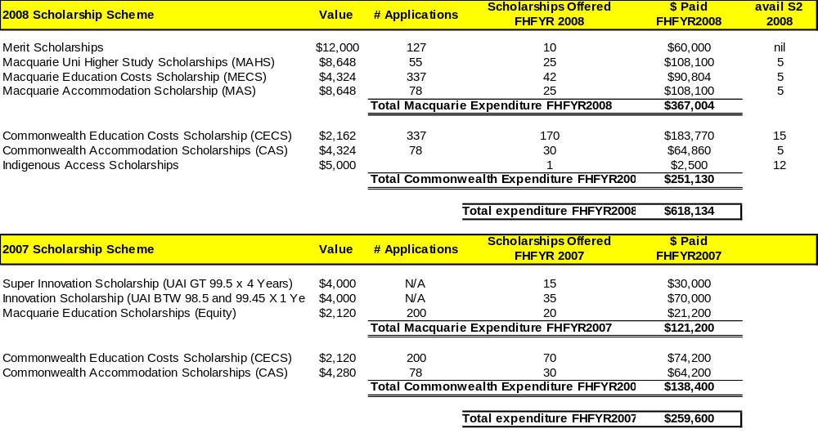
2. Operational
The following actions are underway and expected to be completed early August 2008:
- Undertaking a Focus Group with students eligible for the merit scholar program to draw out their views of its value, what could be included, and whether it influenced their decision to apply to Macquarie.
- Undertaking a survey of current merit scholarship holders to draw out their views of its value, and whether it influenced their decision to apply to Macquarie.
- Undertake a more extensive analysis of competitor scholarships and programs with an objective of clarifying Macquarie’s position in the market in terms of dollar value, eligibility criteria, and range.
- Develop a communications and marketing strategy that will
    - engage both current scholarship holders; and
    - encourage prospective applicants.
- Develop a recruitment and retention strategy targeting Indigenous students
The Coursework Scholarships Unit is also undertaking an analysis of the range of scholarship and prize activity currently available across the university. From this an assessment will be made on further investigation and consultation with stakeholders with a view to centralisation of these activities.
3. Questions - Strategic
The review also raised some questions with regard to the relationship between the University and scholarship holders. These issues included:
- What expectation does the university have of the candidate’s academic performance for continuation of the scholarship?
- What expectation does the university have of the candidate’s community and University engagement?
- What are the reasonable expectations which students can have of the University and of their overall student experience once awarded a scholarship or nominated to the status of Merit Scholar?
The last of these questions is of particular importance to Merit Scholars. Research undertaken through a focus group of current Merit Scholar participants has provided valuable insight into that program. The Executive Summary of the report is attached (refer Attachment 2). Key analysis of the research indicates:
- The current participants do not feel that many academic staff in their Division are aware that they are Merit scholars. They see this recognition as a strong benefit of the program.
- There is a sense that they are being invited to random events that are not designed for them. They would prefer a structured program of designed events specifically for this group.
- They also feel that one of the benefits would be the development of leadership skills.
- They also would like the opportunity to undertake internships.
4. Recommendations
Recommendations from the review are:
- That the Macquarie Scholarships currently requiring Commonwealth scholarship eligibility are indexed relative to increases in the Commonwealth programs.
- That holders of Merit Scholarships and Merit Scholars be expected to maintain a credit average in their studies and to conduct themselves in a manner which is consistent with Macquarie University’s ethical standards and commitment to social inclusion.
- That the Macquarie Scholarship program be reviewed to create scholarships that attract Indigenous students.
Research identifies a number of both university and industry sponsored programs offered by our competitors. Refer Attachment 1
    - That the Indigenous Accommodation scholarship is retained and aligns with the MAS.
    - That Macquarie introduces 10 Indigenous Scholarships with equivalent terms and conditions to the Macquarie Education Costs Scholarships and set at the value of the Macquarie Accommodation Scholarships but with restricted criteria of being available to only Aboriginal and Torres Strait Islander applicants.


  - That the budget be revised to automatically offer the MITS to every mainstream Indigenous student as identified through the Commonwealth definition. The objective of this program is to encourage student retention and allows for an increasing annual payment to recognise continuing studies.
The budget currently allows for 20 students eligible for the initial $1000 ‘top up’ scholarship. It is estimated, there are 35 mainstream indigenous students enrolled in 2008. Whilst allowing for attrition the projected annual expenditure on this program could be $123,000 by 2010.
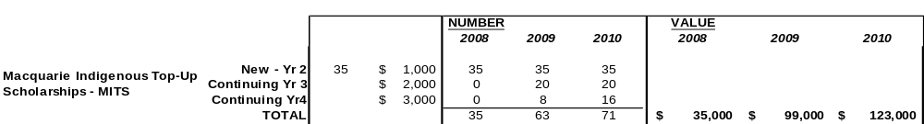

  - That the scholarships review group investigates the possibility of providing financial support to student within the Indigenous ‘block studies’ program.
- That within the new Faculty structure, an appropriate role is identified that provides academic leadership and is accountable for academic governance in the development and delivery of the Merit Scholar Program. The review panel views this Program as highly valuable but entailing reputational risk. The Associate Dean (Learning and Teaching) would be the appropriate role for the oversight of this Program. It is expected this role would liaise with and through the Coursework Scholarships & Prizes Unit which will be accountable for services that support administrative governance of this program.
- That the Coursework Scholarship & Prizes Unit develops a communications strategy to create awareness of the program for both current participants and to attract future candidates. Target groups may include uniTEST participants and Jubilee students.

ATTACHMENT 1: Recommendations – 4.b. Indigenous Scholarships

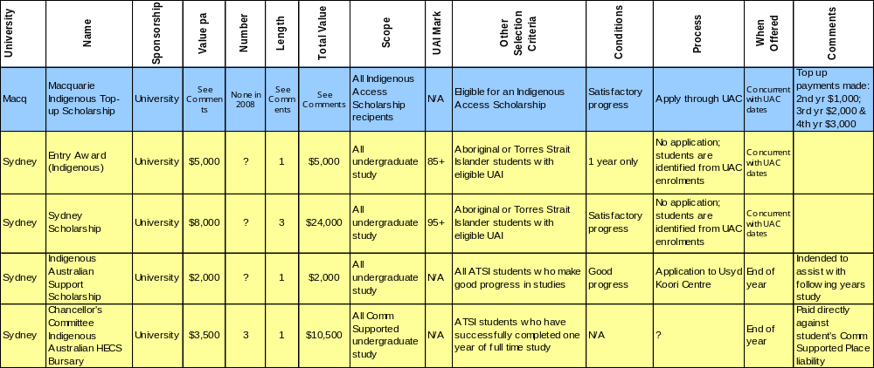
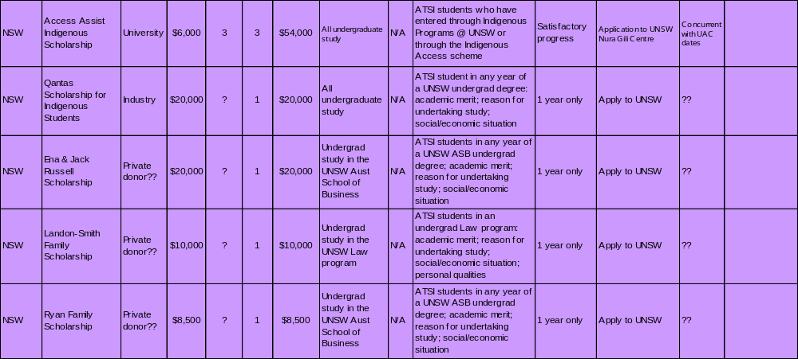

ATTACHMENT 2. FOCUS GROUP REPORT. Executive Summary

Merit Scholars and the Merit Scholarship:
- a review of experiences to date (2008 intake), and
- a brainstorm to develop a program that would attract top undergraduate scholars to Macquarie

Summary of findings
The feedback from these students suggests the Macquarie Merit Scholars program could increase the attractiveness of Macquarie to top scholars, but may not be a reason to come here in its own right, while our UAI course cut-offs are low in comparison with other universities.
The title of ‘Merit Scholar’ was seen as prestigious and the concept of the program is something these students value. We need to make our offering more concrete, co-ordinate it more carefully to increase involvement and promote it more directly to top high school students.
Current Merit Scholars would like to help develop the program and become ambassadors for it, as it becomes a program they truly believe in.

Expectations
Scholarship holders had greater expectations of the program than Merit Scholars without university funding support.
Scholarship holders expected to be known by the head of their department, have access to future research opportunities, develop themselves as leaders, give back to the community, increase their skill base through work experience, broaden their cultural outlook through international exchange, network throughout the university, meet other Merit Scholars and participate in extra-curricular activities.
Non-scholarship holders weren’t sure what to expect, given that the Merit Scholars program is new.

Experiences to date
The actuarial contingent (31 of the 47 scholars) had a more structured experience. They were known to each other and more likely to be known in their department. They had all been hooked up with mentors, most had commenced mentoring sessions and had been to a function for Actuarial Merit Scholars. Their expectations of the program tended to be more directly career-focussed.
For non-actuarial Merit Scholars, their experience of the program was more variable and required more initiative on the part of the Merit Scholar to pursue the opportunities that had been offered to them. Their expectations of the program centred more around participating in a holistic experience.
- Everyone liked the VC’s Welcome Reception, appreciating the chance for a brief exchange with the VC, the heads of department and other Merit Scholars.
- They feel they receive too many emails to events that aren’t designed for them. They don’t go to these events.
- Not everyone reports having a mentor or even the name of a mentor to contact.
- The mentoring sessions are informal and unstructured, often with a research focus. There is a lack of clarity about the purpose of mentoring sessions and how to structure a session.
Students liked the inspiration of meeting with someone ahead of them in their profession. They turned to their mentor with study difficulties they encountered and questions about study direction, subject changes, internships and the marks they needed to get.
- Most don’t feel known in their division.

The ideal program
Perhaps the most highly prized aspect of the program is the access to internships. We need to make our offering here more concrete in terms of how they are structured, the timeframes, involved and how they are accessed. They would like exposure to several organisations for some practical experience, to meet potential employers, to understand what employers are looking for and to list the internship on their resume.
Leadership skills were viewed as important. They wanted to pick these up in practical ways, through meaningful experiences, potentially as volunteers.
Accelerated study options were of interest in terms of testing out subjects outside the scope of their degree and accessing the more interesting third year subjects early. They weren’t so interested in taking on a heavier study load to finish their degree faster.
They want to make friends with other Merit Scholars and feel a part of a community of scholars. They want to meet with other Merit Scholars regularly and have memorable experiences together. They want to utilise a web site to connect with each other, discuss relevant topics, be reminded of upcoming events and find out who’s going to the events. As this is the first year of the program, there is some interest in connecting with scholars ahead of them who’s UAI would have permitted them entry, had we had a program established earlier.
They seek a mentor who will help develop them, in terms of their career goals and professional development, someone who will help them with decisions, advice and support. They would like their mentor to be someone they can relate to and be honest with.
Merit Scholars are interested in events that are career-related, connecting them with professionals working in their field or with other Merit Scholars. We should consider the timing of these events according to their study and examination timetables.
Through the program, they seek to develop a network of contacts – academic, professional, sporting, political and community.
They want to be recognised as an achiever and an important part of the university, and be known to department heads. They seek a holistic experience, not just knowledge acquisition. Merit Scholars want to evolve as a well-rounded mature person who can interact with people of all types. They see this as preparation for their ideal job and to be ‘life ready’.
In terms of providing a quality learning experience for their coursework study, they seek interactive learning experiences, with the opportunity for idea sharing with lecturers and other students. They want to be known to lecturers who take a personal interest in them. They appreciate learning that serves a variety of learning styles – auditory, visual and kinaesthetic.

The scholarship
The Merit Scholarship was the deciding factor for one of the group and the reason to stay here beyond second year for another. The other two chose Macquarie for it’s location. The scholarship allows them to embrace a more rounded educational experience. They are happy to give back to Macquarie through volunteering or advocacy.

Suggestions for marketing, co-ordination and development of the program
- Keep the name – ‘Merit Scholars Program’
- Develop the program in line with a sensible strategy for UAI management
- Enlist the support of Merit Scholars in developing and promoting the program
- Increase participation in the current program
- Make the program offerings and the path for accessing them more concrete
- Promote the program to top high school students in a way that is both concrete and aspirational. Consider developing a glossy brochure and related web page. Engage current Merit Scholars in promoting the program to high school students.
- Ensure 98.5+ students understand and are sold on the benefits of the Merit Scholars Program, independently of any scholarship funding.
- Manage communication to those who missed out on a scholarship with greater awareness of their context, focussing on introducing them into the Merit Scholars cohort.
- Provide a structured, monitored introduction to the Merit Scholars program, where we run through a menu of options, determine what they each seek from it and help them to make connections. Keep in touch with them to monitor what they have participated in, how the program is working for them and make running changes to ensure they get the most out of it.
Consider an approach where we help design, support and monitor their learning experience through the program and encourage self-reflection and shared learning about what they are getting through the program. (This will obviously enhance their experience as well as their ability to be strong advocates for the program).
- Ensure all Merit Scholars have a personal relationship with the head of their department. Consider how their general learning experience in their course areas can be enhanced to include more interactive learning and idea sharing with lecturers and other scholars. Explore opportunities to address different learning styles (auditory, visual, kinaesthetic) and channels (online, face-to-face) in providing interactive learning opportunities.
- Carefully recruit mentors according to agreed criteria. Provide training for mentors about how to structure a session and appropriate communication skills. Clarify the purpose and scope of the mentoring relationship. Check-in with mentors about the progress of sessions and key areas students seek support with. Ask Human Resources to facilitate a learning ‘check-in’ session for mentors so they can debrief problems and further support their own learning in this area.
- Decrease the number of ‘ad-hoc’ emails Merit Scholars receive – perhaps these could be listed on the website instead.
- Design and promote events for Merit Scholars as a cohort, with their needs in mind.
- Have someone from ACES or MGSM design a practical and interactive leadership development program, with learning goals established and outcomes debriefed.
- Enlist industry support for internships for larger, commercial subject areas. Seek opportunities with or on behalf of students from more specialised course areas. Promote benefits of involvement in the program to relevant employers and industry partners.
- Consider how to provide access to counselling to help clarify career goals and guide subject choice, for those in less structured courses.
- Consider opportunities to recognise Merit Scholars as a valuable part of the university community.
- Consider a special Alumni chapter for Merit Scholars.

ATTACHMENT 3. NON-DISCRETIONARY BUDGET



